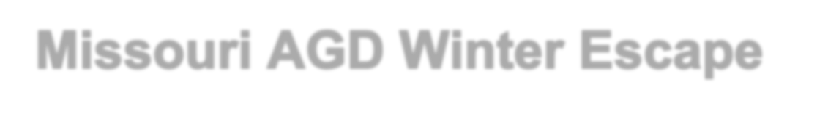

Hello AGD Members and Friends of AGD Members:

To – All Inclusive Adults Only Aruba Resort
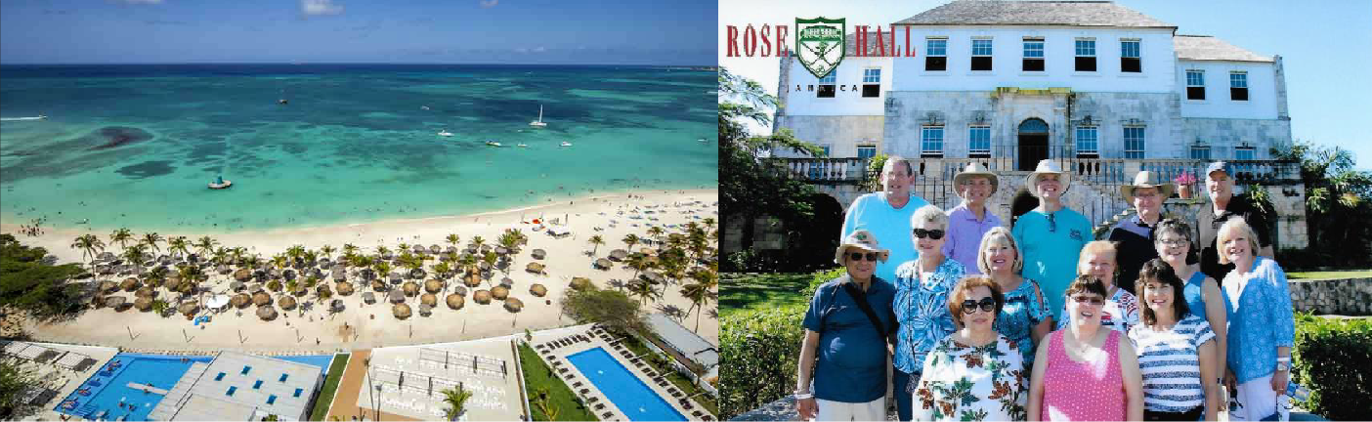

We have chosen to use ” again this year as we have found this to be the best package.

Click on the link below to be taken directly to the FunJets AGD reservation page
http://www.funjet.com/Deals/Deal.aspx?deal=779&vendor=FJ1&promocode=GPAGDGMO19&plcode=GROUPDCT
Everyone needs to book at least their hotel on line through Funjets Vacations so that you receive the group discount and so that our group gets the proper credits.
- First click on the link which will open the AGD Page.
- On the right side of the page is the registration box.
- Select your Package type:
Flight + Hotel - use this choice if you want your flight and Hotel booked by Funjets. Hotel only – use this if you plan to book your own air separately.
- Departure City: You have the ability to choose the city you wish to leave from; St. Louis, Kansas City, Springfield, Columbia, MO , Little Rock, Ark, or ANY OTHER CITY THAT HAS A MAJOR AIRPORT.
- Destination City: Palm Beach, on the Island of Aruba
- Depart: 2/23/2019 Note that the site has a default departure date of 2/18/2019 (that is provided in case you want an earlier arrival date) but the group trip does not start until 2/23/2019
- Return Date: March 2, 2019 (or later if you choose to stay longer)
- Promo Code: GPAGDGMO19

- Hotel Choice: RIU PALACE ANTILLAS – ALL INCLUSIVE ADULTS ONLY RESORT
- After you enter the above information the next page will contain flight information. If the flight times that appear do not meet your liking click change flights and choose the flight times that you would like. Some flights may cost an additional fee but scroll through and choose what suits you.
- Then the next step is to choose your room category (there are several choices.)
- Next select Transfers to and from the hotel this is important because the hotel does not provide transportation (the transfers are $30/person – round trip.)
- If you want travel protection you can choose this too. This is your choice.
- Based on your final cost and according to the discount chart below you should receive a discount from the published price.

Reservation Amount | Promo Code Discount | The appropriate discount will automatically be calculated
$500 - $999.99 | $25 per reservation | based on the reservation amount and will show as a line item
$1,000 - $2,500 | $50 per reservation | on the reservation when making a qualifying reservation.
$2,501 - $5,000 | $100 per reservation | *If anyone needs assistance with their reservation,
$5,001 - $6,000 | $200 per reservation | please contact Funjets Customer Care department at

$6,001 or more $225 per reservation

800-558-3050.

Be sure to use the Promo Code for our group GPAGDGMO19. Group Name: ZZ-DIRECT CONSUMER DIRECT
The applicable promotional code must be entered on any new bookings to receive the promotional discount and to be sure that our group gets the proper credits.
We encourage you to make your reservations early since rates may change.

Once you have made your reservation please forward an email to Sharon Dear deardav1@sbcglobal.net and Phyllis Zust pzust@outlook.com so that they can keep track of who will be joining us. If you should have any questions please feel free to email Sharon or Phyllis and they will help you with any questions you may have.

Thanks so much and I hope you will join us on our 5 th annual trip of the Missouri AGD Winter Escape which this year will take place on the beautiful island of Aruba.

Sincerely,
David J. Dear, DDS, MAGD
Missouri Academy of General Dentistry, Treasurer

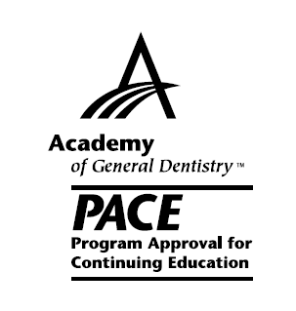
Academy of General Dentistry
Approved PACE Program Provider
FAGD/MAGD Credit
Approval deos not implant acceptance by a state or
Provinvial board of dentistry or AGD endoresment
01June2018-31May2021

